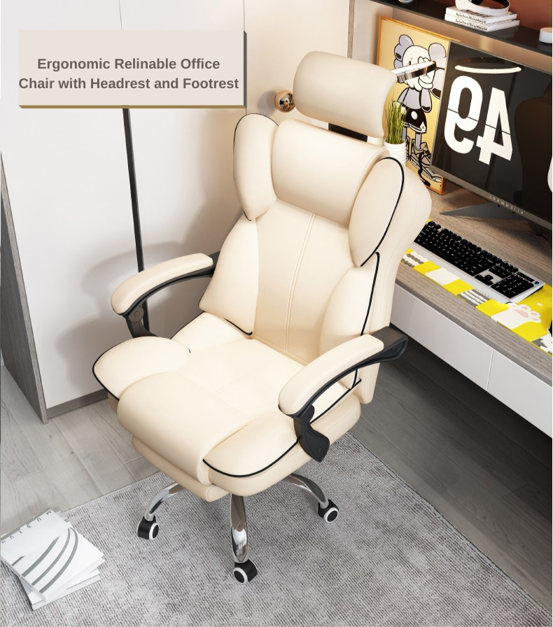  1 | Ergonomic Relinable Office Chair with Headrest and Footrest  Black | €22.42

Subtotal | €22.42
Shipping | + €10.08

