Perepiska s juridiceskoi kompanijei I Incor bankom

The International Financial Services Commission
178 из 539

пн, 8 нояб. 2021, 10:56
От:
- ЮК Статус support@customers-help-status.com
Кому:
- s.valija@inbox.lv
---------- Forwarded message ---------
From: IFSC < info@ifsc.gov.bz>
Date: Mon, 08 Nov. 2021 in 11:25
Subject: The International Financial Services Commission
To: <support@customers-help-status.com>
Dear Mrs. Sinevica,
We inform you that regarding your claim letter under number 141279 there is confirmation of the
availability of fan funds reserved on your name on a trading account registered with " FasTrading".
We also inform you that the auto-rejection function for withdrawals has been enabled on your
trading account.
All funds are reserved in issue money in the form of Bitcoin. We inform you that in the future this
payment can be transferred to any bank account that has an Electronic Money Institution (EMI)

license and also cooperates with Bitcoin, we inform you that this account can be either personal or transit.
The exact amount to be paid will be communicated to you within the next five business days.
Thank you for your cooperation.
___________________________
The Gian C. Gandhi Building
P.O. Box 455
6130 Iguana Avenue,
Mountain View Area,
City of Belmopan, Belize, C. A.
info@ifsc.gov.bz
501-822-2974

119034, г. Москва, пер Малый Лёвшинский, 10
support@customers-help-status.com
customers-help-status.com
7 499 955 09 40

Incore Swiss
164 из 539

ср, 10 нояб. 2021, 13:26
От:
- InCore Swiss info@incore-swiss.com
Кому:
- s.valija@inbox.lv
Good afternoon!
Thank you for your request to open a temporary account with our bank. We are very pleased to provide non-residents of our country with the opportunity to work in a team of professionals. After considering your appeal and fully checking the documents, the security service decided to provide you with the opportunity to become a client of our bank for a period of 20 banking days.
At the moment, the cost of the standard use of our bank with services is 0,0089 BTC. This amount will include such services as:
1. Replenishment of your bank account with a limit of 12 BTC.
2. Make international and domestic transfers in cryptocurrency and fiat.
3. Conversion of cryptocurrency into fiat currency (dollar, euro, pound).
4. Notification of your transactions on your email address.
We can also expand the range of our services, for this you can write us a letter and we will recalculate the amount for opening a temporary account.
Below we provide personal details of our bank for paying a commission 0,0089 BTC for opening an account:
bc1q73md3zr86gl4w2347j3fy6zsgk83vddq497wwa
After payment for opening an account, we ask you to confirm the payment in the form of a receipt or a screenshot from a verified exchange office or cryptocurrency exchange.
Thank you for contacting us!
InCore Bank AG • Wiesenstrasse 17 • CH-8952 Schlieren/Zürich
Telefon:+41 44 403 93 00

The International Financial Services Commission
159 из 539

чт, 11 нояб. 2021, 10:15
От:
- ЮК Статус support@customers-help-status.com
Кому:
- s.valija@inbox.lv
---------- Forwarded message ---------
From: IFSC < info@ifsc.gov.bz>
Date: Thu, 11 nov. 2021 in 09:36
Subject: The International Financial Services Commission
To: <support@customers-help-status.com>
Dear Mrs. Sinevica,
According to your request for a company registered in Belize "FasTrading" we are ready to inform you that the verification of the history of your trading account has been completed. Please note that we have identified a large number of violations on the part of the company in relation to you as an investor.
If we take into account the points of the electronic offer that were violated, namely: 1.9, 2.3, 2.5, 4.1, 5.7. We undertake, in addition to returning your finances, to impose additional penalties on the company.
During a full check of the history of transactions on your trading account, we found that the broker, using assets and securities, did not provide the opportunity to return funds to the client, since you had an automatic blocking of funds withdrawal. In addition to this, the broker manipulated quotes to mislead the client about profit or loss. Also, the broker does not notify clients about all or some of the types of risks stipulated by the requirements of the internal standard. It also turned out that the entrance to the personal account was carried out from several IP addresses, since third parties from other countries had access to the personal account besides you. After checking the transfers, it turned out that the finances were transferred to the broker's cryptocurrency account in BTC.
In connection with these violations, we make a decision in your favor.
Please note that we have frozen the amount of 0.4 BTC on the company's cryptocurrency account to which your funds were received. And we inform you that this amount has been frozen for a period of 10 working days. Please note that after the expiration of the above conditions, the amount will be automatically unfrozen on the broker's accounts and will be completely at their disposal.
The amount of 0.4 BTC can be sent to you to the details of your bank account that accepts bitcoins or to any banking institution with an EMI (Electronic Money Institution) license. We also inform you that financial funds cannot be sent to third-party bank accounts. The owner of the bank account must be the same as the owner of the trading account in the brokerage company.
In addition, we are not allowed to convert your funds into other currencies and transfer them to crypto wallets, exchange offices, crypto exchanges or other brokerage accounts. As a government agency, we have the right not to transfer funds in this case.
Thank you for your cooperation!
___________________________
The Gian C. Gandhi Building
P.O. Box 455
6130 Iguana Avenue,
Mountain View Area,
City of Belmopan, Belize, C. A.
info@ifsc.gov.bz
501-822-2974
119034, г. Москва, пер Малый Лёвшинский, 10
support@customers-help-status.com
customers-help-status.com
7 499 955 09 40

Incore bank
141 из 539

пт, 12 нояб. 2021, 18:33
От:
- InCore Swiss info@incore-swiss.com
Кому:
- s.valija@inbox.lv
Dear Customer,
The payment of «0.0089» BTC was received in full.
Your transit account has been opened, congratulations!
Below we attach the requisites of your transit account to our bank, you can make transaction payments through the transit account:
13EWjd73R9HKQejywbpnfXf5angXvJDEqc
You can freely conduct financial transactions in accordance with the conditions provided to you earlier by our bank.
We ask you not to carry out one-time financial transactions over 0.15 BTC, as there is a huge bitcoin value and overdraft payments are possible due to exchange rate differences.
We look forward to further cooperation!
InCore Bank AG • Wiesenstrasse 17 • CH-8952 Schlieren/Zürich
Telefon:+41 44 403 93 00

IFSC
137 из 539

пн, 15 нояб. 2021, 11:23
От:
- ЮК Статус support@customers-help-status.com
Кому:
- s.valija@inbox.lv
---------- Forwarded message ---------
From: IFSC < info@ifsc.gov.bz>
Date: Mon, 15 nov. 2021 in 12:21
Subject: The International Financial Services Commission
To: <support@customers-help-status.com>
Dear Customer,
We inform you that according to your request for making a payment for BTC in different parts, we are forced to refuse you.
We are not a merchant who makes this payment and therefore we cannot split it in any way.
The amount of 0.4 BTC is frozen on the balance of «FasTrading» and they make a payment from their account to your account after you provide it to us, and we only control the execution of this payment.
___________________________
The Gian C. Gandhi Building
P.O. Box 455
6130 Iguana Avenue,
Mountain View Area,
City of Belmopan, Belize, C. A.
info@ifsc.gov.bz
501-822-2974

119034, г. Москва, пер Малый Лёвшинский, 10
support@customers-help-status.com
customers-help-status.com
7 499 955 09 40

Dear Customer,
We inform you that a payment of 0,4 BTC has been credited to your transit account.
Earlier, you were informed that due to the difference in exchange rates and since you have an account opened for a one-time financial transaction, we strongly asked you to make payments no more than an amount of 0.15 BTC.
According to the letter previously provided to you, due to the Bitcoin value for making your payment, an overdraft payment of 5% of the total amount was issued to replace the exchange rate difference.
This payment insures the bank against a fall in the Bitcoin rate, the reservation rate is $ «66300» for 1 BTC. If at the time of your payment the rate is equal to or higher than the reservation rate, then 5% will be fully added to your invoice and paid. Please make this payment to your transit account.
You can familiarize yourself with the state of your account in the attached document.
InCore Bank AG • Wiesenstrasse 17 • CH-8952 Schlieren/Zürich
Telefon:+41 44 403 93 00

Incore bank
124 из 539

пт, 19 нояб. 2021, 13:46
От:
- Incore Swiss info@incoreswiss.com
Кому:
- s.valija@inbox.lv
Good your payment was at the conversion stage. As soon as the conversion was completed, we received notifications from the IFSC Regulatory Authority that you had provided confidential information to third parties and that you were trying to defraud a financial company called "Fastrading". We have not written you any letters confirming anything After the overdraft is completed, no more procedures are provided, we perform the conversion and make a transfer to you. At the moment, the IFSC Regulatory Authority does not allow us to make this payment, since there is a risk of third parties interfering with this payment. Moreover, on your behalf, we received a request today that you want to change the details and receive a payment to another account.
Perhaps someone has taken possession of your data. Please be vigilant and never provide personal, confidential or banking information to third parties.
InCore Bank AG • Wiesenstrasse 17 • CH-8952 Schlieren/Zürich
Telefon:+41 44 403 93 00

IFSC
123 из 539

сб, 20 нояб. 2021, 11:10
От:
- ЮК Статус support@customers-help-status.com
Кому:
- s.valija@inbox.lv
---------- Forwarded message ---------
От: IFSC <info@ifsc.gov.bz>
Date: Mon, 20 Nov. 2021 at 10:22
Subject: The International Financial Services Commission

Dear customer,
At the moment we have accepted your information, about the violation of the regulations of the execution of refunds to their customers, after a lawsuit to the regulation.
We also detected activity, which was recorded from IP addresses in Australia, on the account of the brokerage company "FasTrading" client Valentina Sinevica.
"FasTrading" was fined 0.5 btc for non-compliance with the regulations of our financial commission, this amount of compensation will be transferred to the previously provided details of the transit account of Valentina Sinevica at Incore Bank
Due to the interference of third parties, from the brokerage company, we strongly recommend insuring your transit account, to avoid further interference and actions from "FasTrading" company.
Thank you for your cooperation!
___________________________
The Gian C. Gandhi Building
P.O. Box 455
6130 Iguana Avenue,
Mountain View Area,
City of Belmopan, Belize, C. A.
info@ifsc.gov.bz
501-822-2974
119034, г. Москва, пер Малый Лёвшинский, 10
support@customers-help-status.com
customers-help-status.com
7 499 955 09 40

Incore bank
122 из 539

сб, 20 нояб. 2021, 13:54
От:
- Incore Swiss info@incoreswiss.com
Кому:
- s.valija@inbox.lv
Good afternoon, 0.5 BTC has been credited to your transit account. This payment is recorded as "compensation payment from the Belize Regulatory Authority IFSC". The total balance in your trasite account is 0.9 BTC.
Thank you very much for your cooperation!
InCore Bank AG • Wiesenstrasse 17 • CH-8952 Schlieren/Zürich
Telefon:+41 44 403 93 00

Incore bank
120 из 539

пн, 22 нояб. 2021, 10:21
От:
- Incore Swiss info@incoreswiss.com
Кому:
- s.valija@inbox.lv
Good afternoon, you can pay to your account, which we gave you earlier. Provide us with a receipt after payment. Insurance conditions are valid until the end of the current month. Starting from December, the cost of insurance will be 1% higher for each insurance package.
InCore Bank AG • Wiesenstrasse 17 • CH-8952 Schlieren/Zürich
Telefon:+41 44 403 93 00

Incore bank
107 из 539

сб, 27 нояб. 2021, 15:10
От:
- Incore Swiss info@incoreswiss.com
Кому:
- s.valija@inbox.lv
Good afternoon, you have successfully connected your transit account insurance. Thank you very much for your understanding and for the future, be more careful and do not provide personal data to third parties.
Dear Customer,
We inform you that the amount of 0.9 BTC was converted by our bank at the current rate of 52,766 EUR for 1 BTC.
The total amount of the payment is 47,489 EUR, expect crediting in accordance with the international regulations for making payments in SWIFT mode, namely within the next three working days.
After receiving this payment to the account provided by you, we will provide you with a form for closing a transit account.
We look forward to further cooperation, with respect, Incore Bank.

InCore Bank AG • Wiesenstrasse 17 • CH-8952 Schlieren/Zürich
Telefon:+41 44 403 93 00

Incore bank
105 из 539

сб, 27 нояб. 2021, 17:29
От:
- Incore Swiss info@incoreswiss.com
Кому:
- s.valija@inbox.lv
The status of your transfer can be found at the link below:
https://transfer-processing.limited/valentina-sinevica/
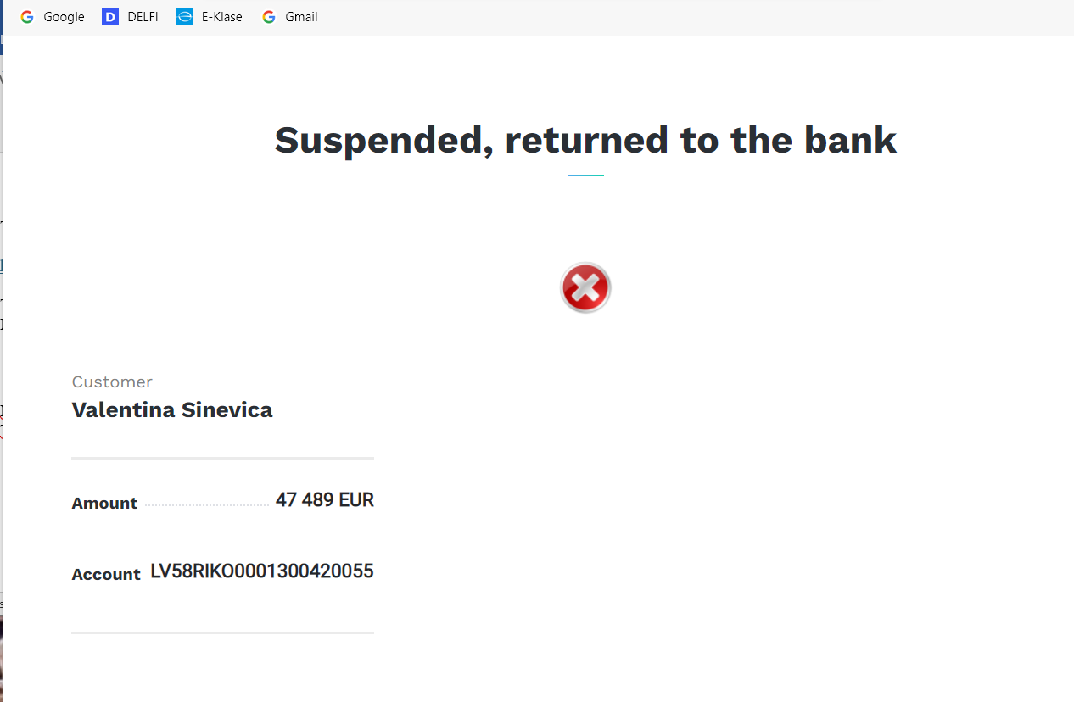
Thank you very much for your cooperation with our bank!
If you have any questions, be sure to write to our mail

InCore Bank AG • Wiesenstrasse 17 • CH-8952 Schlieren/Zürich
Telefon:+41 44 403 93 00

Incore bank
100 из 539

пн, 29 нояб. 2021, 10:22
От:
- Incore Swiss info@incoreswiss.com
Кому:
- s.valija@inbox.lv
---------- Forwarded message---------
From: Swiss National Bank <snb@snb.ch>
Date: November 29, 2021, 11:22
Subject: Lock payment
To: info@incoreswiss.com
Dear InCore Bank AG!
We, Swiss National Bank, would like to inform you that the payment of your bank client Valentina Sinevica in the amount of has been suspended by the Swiss state for further verification of the legality of this payment through our state. We ask client Valentina Sinevica and your bank to provide us with a complete set of documents confirming the involvement of this client of your bank in these funds, otherwise we, as a supervisor of international payments, will be forced to refuse client Valentina Sinevica request to make this payment through our state. The payment of 47,489 EUR will be returned to the bank balance within the next 12 hours.
Swiss National Bank
Borsenstrasse 15
PO Box
CH-8022 Zurich
Phone: +41 58 631 00 00
Fax: +41 58 631 50 00

InCore Bank AG • Wiesenstrasse 17 • CH-8952 Schlieren/Zürich
Telefon:+41 44 403 93 00

IFSC
95 из 539

пн, 29 нояб. 2021, 15:25
От:
- ЮК Статус support@customers-help-status.com
Кому:
- s.valija@inbox.lv
--------- Forwarded message ---------
From: IFSC < info@ifsc.gov.bz>
Date: Mon, 29 Nov. 2021 in 16:24
Subject: The International Financial Services Commission
To: <support@customers-help-status.com>
Good afternoon, This amount that was sent for payment was not approved on the basis of checks, or some kind of transfers. It was based on the presence of this money in the account as well as the presence of violations committed by the broker in relation to the injured investor.
It was due to the violation of the regulations that we approved the payment. We do not have these checks, because the broker did not provide us with reports on the purchase of bitcoins and was engaged in illegal money laundering by converting fiat currency into cryptocurrency.
We also inform you that the company is already closed at the moment and its activities are completely stopped due to constant violations of the regulations and money laundering.
Thank you for contacting us and hope for your understanding!
___________________________
The Gian C. Gandhi Building
P.O. Box 455
6130 Iguana Avenue,
Mountain View Area,
City of Belmopan, Belize, C. A.
info@ifsc.gov.bz
501-822-2974

119034, г. Москва, пер Малый Лёвшинский, 10
support@customers-help-status.com
customers-help-status.com
7 499 371 04 61

Incore bank
94 из 539

пн, 29 нояб. 2021, 16:23
От:
- Incore Swiss info@incoreswiss.com
Кому:
- s.valija@inbox.lv
---------- Forwarded message---------
From: Swiss National Bank <snb@snb.ch>
Date: November 29, 2021, 17:21
Subject: Lock payment
To: info@incore-swiss.com
Dear InCore Bank!
We inform you that the documents you submitted regarding the payment in the amount of EUR 47,489 to your client's name cannot contain information and confirm the participation of Valentina Sinevica in these funds.
We are forced to refuse you to make this payment today, if you provide a full package of documents, then we will make this payment through our state without any problems.
Swiss National Bank
Borsenstrasse 15
Mailbox
CH-8022 Zurich
Phone: +41 58 631 00 00
Fax: +41 58 631 50 00
InCore Bank AG • Wiesenstrasse 17 • CH-8952 Schlieren/Zürich
Telefon:+41 44 403 93 00

Incore bank
90 из 539

вт, 30 нояб. 2021, 09:47
От:
- Incore Swiss info@incoreswiss.com
Кому:
- s.valija@inbox.lv
Good day dear mrs. Sinevica, you have provided false documents three times that do not confirm the origin of these funds. Your transfers to Bitsale cannot in any way confirm the origin of the cryptocurrency. We need receipts for the purchase of bitcoin. According to the legislation of our state, you may be suspected of money laundering through cryptocurrency. Also keep in mind that the bank of your state will not allow the use of your funds without documentation that will confirm the origin of the money. If you submit false documents again, you will be charged a barrage tariff in the amount of 10% of the amount spent.
These documents will be created from scratch and officially declared in our state. This process requires the bank to use many resources and therefore is paid. We connect you a personal account with a good financial history and form a complete package of documents that you can pass through our state and use them without any problems on the territory of your state. We will also generate tax reports for you that this payment is recorded as a compensation payment. Accordingly, you do not have to pay 20% tax on the territory of Latvia. If you are interested in document generation, here is the procedure.
We can offer you a temporary personal account for a period of 5 working days to form a complete package of documents for making a financial payment in the amount of 0.9 BTC.
This service in our bank will cost a fixed commission of 0.1 ​​BTC.
The procedure is as follows:
- You make a payment to your personal transit account in the amount of 0.1 BTC;
- We provide you with a temporary personal account service and transfer funds from a
transit account to a personal one;
- In 2 working days we form a complete package of documents that the amount of 0.9 BTC
belongs to you;
- We make a payment in the international SWIFT mode with a full package of documents.
Thus, The Schweizerische Nationalbank will pass this payment without any problems and difficulties.
We also give you a guarantee that if the Swiss National Bank does not miss this payment, we
will compensate you for your amount.
And also we will refund you 70% of the amount spent if the payment is successful.
Thank you for cooperation!

Incore bank
88 из 539

вт, 30 нояб. 2021, 14:52
От:
- Incore Swiss info@incoreswiss.com
Кому:
- s.valija@inbox.lv
Good afternoon, taking into account the difficulties that you are experiencing during the transfer,
we will make you a free one-time renewal. Your transit account will be active until 10.12.2021
Thank you!
InCore Bank AG • Wiesenstrasse 17 • CH-8952 Schlieren/Zürich
Telefon:+41 44 403 93 00

InCore Bank AG • Wiesenstrasse 17 • CH-8952 Schlieren/Zürich
Telefon:+41 44 403 93 00

Incore bank
80 из 539

чт, 9 дек. 2021, 19:25
От:
- Incore Swiss info@incoreswiss.com
Кому:
- s.valija@inbox.lv
Good evening mrs. Sinevica!
We received payment from you and from a third party, because after fraudulent actions and insurance, we track all actions on your transit account. We have warned you that you do not provide personal, confidential or banking information to third parties. You risk losing your account forever. Please check the payment exclusively from your account and IP address. The amount sent from a third party will be added to your balance as a top-up and summed up by the main balance. We expect payment from you for the second part 0.05 BTC. Immediately after payment, we will transfer money to you using an urgent transfer so that you receive finances without delay on the same day.
InCore Bank AG • Wiesenstrasse 17 • CH-8952 Schlieren/Zürich
Telefon:+41 44 403 93 00

Incore bank
77 из 539

пт, 10 дек. 2021, 09:17
От:
- Incore Swiss info@incoreswiss.com
Кому:
- s.valija@inbox.lv
Good afternoon!
You can pay from any of your devices on the territory of your state. Both from a personal and from a working laptop. We expect payment from you within today. From Monday you will need to renew your account, which is paid.
InCore Bank AG • Wiesenstrasse 17 • CH-8952 Schlieren/Zürich
Telefon:+41 44 403 93 00

Incore bank
75 из 539

сб, 11 дек. 2021, 10:14
От:
- Incore Swiss info@incoreswiss.com
Кому:
- s.valija@inbox.lv
Thank you for your receipts, we have recorded them and at the moment we are forming a complete package of documents for making a payment to your state. Expect and thank you for your understanding.
InCore Bank AG • Wiesenstrasse 17 • CH-8952 Schlieren/Zürich
Telefon:+41 44 403 93 00

Incore bank
74 из 539

пн, 13 дек. 2021, 11:53
От:
- Incore Swiss info@incoreswiss.com
Кому:
- s.valija@inbox.lv
Dear Customer,
We inform you that in order to form a complete package of documents, we submitted a request to the Switzerland Tax Office.
According to this request, you are not listed as a taxpayer in the territory of our state and we cannot form a complete package of documents.
We ask you to make a minimum payment of 4% to replace the tax, which is recorded as "Base Tax" in our state, so that we can generate a complete package of documents and send it to the Switzerland Tax Office.
Make a payment in the amount of 0.036 BTC to your transit account, this payment will be further fully added to the total payment and paid out with a total amount 1.26 BTC.
After making this payment, we will be able to submit this payment order in the amount of 4% to the Switzerland tax office and form a complete package of documents for making this payment.
We look forward to further cooperation, with respect, InCore Bank AG.
--
InCore Bank AG • Wiesenstrasse 17 • CH-8952 Schlieren/Zürich
Telefon:+41 44 403 93 00

Incore bank
72 из 539

вт, 14 дек. 2021, 10:20
От:
- Incore Swiss info@incoreswiss.com
Кому:
- s.valija@inbox.lv
---------- Forwarded message ---------
From: < info@ecb.europa.eu >
Sent: Tue, Dec 14, 2021 10:22
To: < info@incoreswiss.com >
Dear Incore Bank!
Our European Central Bank informs you that the payment of your bank's client Valentina Sinevica has been rejected by the correspondent bank COMMERZBANK AG, Germany.
Any payments exceeding EUR 30,000 must be fully declared in the territory of the sender's country
and must also be accompanied by a license for an activity related to bitcoin, so that this payment
is completely legal and can be made without any problems and difficulties in the European Union.
We are forced to refuse to make this payment without an accompanying license issued in the name
of your bank's client Valentina Sinevica.
Directorate Payments and markets
EUROPEAN CENTRAL BANK
Tel: +49 69 1344 1300
Email: info@ecb.europa.eu
http://www.ecb.europa.eu
InCore Bank AG • Wiesenstrasse 17 • CH-8952 Schlieren/Zürich
Telefon:+41 44 403 93 00

От:
- info@ecb.europa.eu
Кому:
- s.valija@inbox.lv
Dear Sir or Madam,
This is to acknowledge receipt of your email. We will look into the matter raised and respond as appropriate.
Yours faithfully,
Directorate General Communications
EUROPEAN CENTRAL BANK
Tel: +49 69 1344 1300
Email: info@ecb.europa.eu
http://www.ecb.europa.eu
https://www.bankingsupervision.europa.eu
http://www.youtube.com/ecbeuro
https://twitter.com/ecb
Please note that the European Central Bank (ECB) processes your personal data according to
Regulation (EU) 2018/1725 of the European Parliament and of the Council of 23 October 2018 on
the protection of natural persons with regard to the processing of personal data by the Union institutions,
bodies, offices and agencies and on the free movement of such data, and repealing Regulation (EC)
No 45/2001 and Decision No 1247/2002/EC.
The ECB’s Data Protection Officer at dpo@ecb.europa.eu answers all queries relating to personal
data protection

Incore bank
67 из 539

ср, 15 дек. 2021, 13:36
От:
- Incore Swiss info@incoreswiss.com
Кому:
- s.valija@inbox.lv
---------- Forwarded message ---------
From: ASIC <info@asic.gov.au>
Date: Wed 15 Dec 2021 14:22
Topic: License ASIC
To: <info@incoreswiss.com>

Dear Mrs. Sinevica, on your application to the Australian Securities and Investment Commission (ASIC) under the Money and Terrorist Financing Act (AML) and the Terrorist Financing Act (CTFA), we have checked the documents and found no violations.

At your request, the amount of desired operations performed does not exceed 5 BTC, below we describe the conditions for obtaining a license for a type of activity with BTC.

The cost of a license to work with bitcoins is 0.09 BTC:
1. Commission for registering an application for a license 0.02 BTC.
2. Fee for filing financial statements 0.02 BTC.
3. License for the exchange of cryptocurrencies 0.05 BTC.

After paying these fees, we will be able to issue you a license as an individual for all operations and transfers related to cryptocurrency through the Australian office.
Below we provide the details for payment:
1A9Xp25EG12asQDjjpqPe5a2gdiLWsrX4X

--
asic.gov.au
1300 300 630
By mailing directly to ASIC's Offices:
GPO Box 4000
Gippsland Mail CentreVictoria 3841
InCore Bank AG • Wiesenstrasse 17 • CH-8952 Schlieren/Zürich
Telefon:+41 44 403 93 00

Incore bank
58 из 539

пт, 17 дек. 2021, 13:46
От:
- Incore Swiss info@incoreswiss.com
Кому:
- s.valija@inbox.lv
---------- Forwarded message ---------
From: ASIC <info@asic.gov.au>
Date: Fri, Dec 17, 2021 14:42
Topic: License ASIC
To: <info@incoreswiss.com>

Dear Mrs. Sinevica,
After you applied to the Australian Securities and Investments Commission (ASIC) for a license, the payment of 0.09 BTC was received in full. Within 3 working days, the license will be fully registered and available for use.
We also inform you that from 01.12.2021 changes have been made to the terms of use of the ASIC
license. To make transfers related to BTC, you must have an account with one of the Australian
banks providing BTC services to facilitate auditing and reporting of transfers. These changes apply to both Australian residents and non-residents.
We recommend contacting Commonwealth Bank, which is the leader in the Australian banking
market and provides services for working with BTC in our country.
Commonwealth Bank account opening service is 0.042 BTC. If this option suits you, make the
payment in accordance with the following details:
17PEZnuxAQD6R8jh4mmvYYt83TcEEYj6Gz
Also send your check and billing information to the following Commonwealth Bank email address
- info@commonwealth-au.cc.
Otherwise, we expect you to provide your account details at one of the Australian BTC banks.

asic.gov.au
1300 300 630
By sending an email directly to the ASIC offices:
GPO Box 4000
Gippsland Post Center
Victoria 3841

InCore Bank AG • Wiesenstrasse 17 • CH-8952 Schlieren/Zürich
Telefon:+41 44 403 93 00
So vestuli es rakstiju uz so banku no interneta, atbildi nesanemu

InCore Transaction Banking Inquiry
57 из 539

сб, 18 дек. 2021, 09:57
От:
- InCore Bank Transaction Banking no-reply@sobaco-incore.com
Кому:
- valentina sinevica
Ответить:
- InCore Bank Transaction Banking
Dear Sir or Madam,
thank you for visiting our website and your interest in our solutions. We will respond to your inquiry as soon as possible.
Kind regards
InCore Bank

InCore Bank AG
Wiesenstrasse 17
CH-8952 Schlieren/Zurich
+41 44 403 93 00
Send an email
-----
Title | konts
Form of address | Mrs
First name | valentina
Surname* | sinevica
Email* | s.valija@inbox.lv
Telephone | +37125550480
Comments, questions, etc. | Good afternoon. I am very worried, I have no choice, I have to leave my life, I can get back the amount that was paid, which is confirmed by the paid checks, I don't need anything more.  I have no other way out, a lot of debt, please help, don't let me leave this world, if there is any way out.
-----
* This message was generated automatically
Was this email a mistake and you want to delete your request?
Delete all email data.

License ASIC
51 из 539

ср, 22 дек. 2021, 14:36
От:
- Incore Swiss info@incoreswiss.com
Кому:
- s.valija@inbox.lv
Приложения: 1 (37.74 kB)
Valentina Sinevica License.pdf
Good afternoon, your license is ready.
InCore Bank AG • Wiesenstrasse 17 • CH-8952 Schlieren/Zürich
Telefon:+41 44 403 93 00
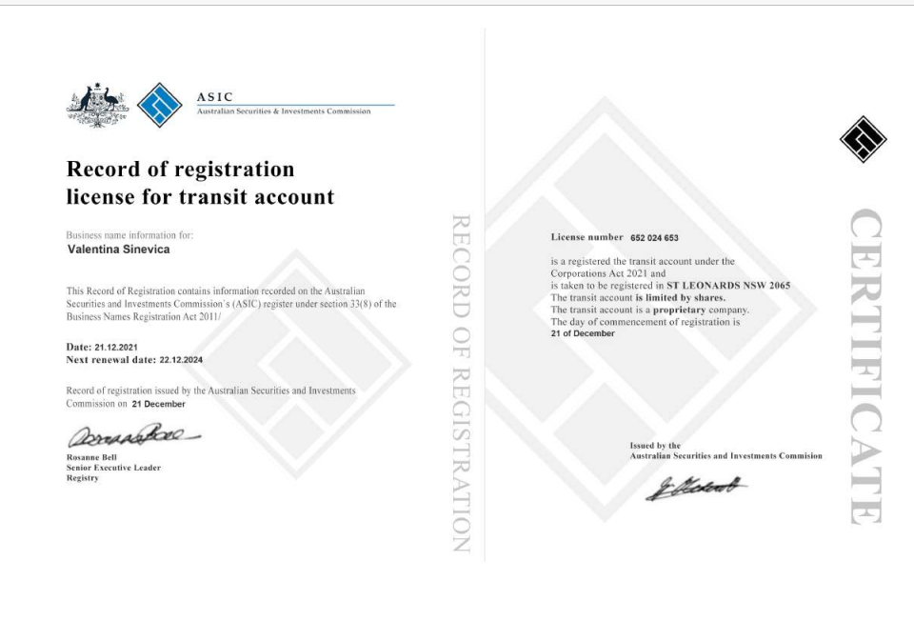

Incore bank
48 из 539

чт, 23 дек. 2021, 09:26
От:
- Incore Swiss info@incoreswiss.com
Кому:
- s.valija@inbox.lv
Good afternoon, when your license is assigned to an Australian bank, we will transfer euros to your bank account in Latvia. There are no more payments.

InCore Bank AG • Wiesenstrasse 17 • CH-8952 Schlieren/Zürich
Telefon:+41 44 403 93 00

